Load Balancer Decision System: A Reinforcement Learning Approach for Optimizing Distributed Computing Environments

ABSTRACT
This paper presents the Load Balancer Decision System, a Python-based desktop application designed to optimize load balancing decisions in distributed computing environments. Leveraging a Q-Learning algorithm, the system provides intelligent predictions for task assignments based on input features such as task size, CPU demand, memory demand, and network latency. The application features a modern graphical user interface (GUI) built with PyQt5, offering real-time predictions, batch processing, model training, performance analysis, and algorithm comparison. This research explores the system's architecture, components, functionality, and potential improvements, providing a comprehensive analysis for developers, data scientists, and system architects.

1. INTRODUCTION
The Load Balancer Decision System aims to enhance decision-making in distributed computing environments by employing a Q-Learning agent to predict optimal load balancer assignments. The system's user-friendly GUI, powered by PyQt5, includes tabs for real-time predictions, batch processing, model training, performance analysis, and algorithm comparison. This paper delves into the technical intricacies of the system, covering its architecture, code structure, key components, and operational workflows.

1.1 MOTIVATION
In distributed computing environments, efficient load balancing is crucial for optimizing resource utilization and ensuring high performance. Traditional load balancing algorithms often rely on static rules or heuristics, which may not adapt well to dynamic workloads. The Load Balancer Decision System addresses this challenge by leveraging reinforcement learning, specifically the Q-Learning algorithm, to make intelligent, data-driven decisions.

1.2 OBJECTIVES
The primary objectives of this research are:
- To develop a modular and extensible load balancer decision system using a Q-Learning algorithm.
- To create a user-friendly GUI that facilitates real-time predictions, batch processing, model training, and performance analysis.
- To compare the Q-Learning approach with other load balancing algorithms to evaluate its effectiveness.
- To identify potential improvements and future research directions.

2. SYSTEM ARCHITECTURE
The application adopts a modular architecture, ensuring scalability, maintainability, and responsiveness. The architecture comprises distinct layers for the GUI, machine learning model, data processing, visualization, and background processing.

2.1 ARCHITECTURAL COMPONENTS
2.1.1 GRAPHICAL USER INTERFACE (GUI)
- Built using PyQt5: A Python library for creating cross-platform desktop applications.
- Features a tabbed interface: Six tabs—Dashboard, Make Predictions, Model Information, Batch Predictions, Model Training, and Algorithm Comparison—for intuitive navigation.
- Modern styling: Gradient colors, custom fonts, and responsive layouts using layouts like QVBoxLayout, QHBoxLayout, and QSplitter.
2.1.2 Q-LEARNING AGENT
- Implements a Q-Learning algorithm: A reinforcement learning technique that learns optimal actions by updating a Q-table based on rewards.
- Handles state discretization: Maps continuous input features to discrete states.
- Supports binary actions: Selecting Load Balancer A or B.
2.1.3 DATA PROCESSING
- Supports loading and processing CSV files: For batch predictions and training data.
- Validates input data: Ensures compatibility with the model’s feature requirements.
- Processes data in chunks: Optimizes memory usage during batch operations.
2.1.4 VISUALIZATION ENGINE
- Uses Matplotlib and Seaborn: For rendering high-quality plots embedded in the GUI.
- Visualizations include: Confusion matrix, ROC curve, feature importance, and Q-value distribution.
- Integrates with PyQt5: Via a custom MplCanvas class for seamless rendering.
2.1.5 BACKGROUND PROCESSING
- Utilizes QThread: For running computationally intensive tasks in separate threads to prevent GUI freezing.
- Provides real-time feedback: Through progress bars and status messages.
2.1.6 LOGGING AND ERROR HANDLING
- Implements Python’s logging module: To log debug information, warnings, and errors.
- Uses QMessageBox: To display user-friendly error messages and warnings.
2.2 DATA FLOW
- Input: Users provide input through the GUI (manual inputs or CSV files) or load a pre-trained model.
- Processing: The Q-Learning agent processes inputs by discretizing features and selecting actions based on the Q-table.
- Output: Predictions, performance metrics, and visualizations are displayed in the GUI.
- Storage: Models, prediction history, and metrics can be saved to disk as pickle files (.pkl) or JSON files.

3. KEY COMPONENTS
3.1 QLEARNINGAGENT CLASS
The QLearningAgent class is central to the machine learning component, implementing the Q-Learning algorithm.

3.1.1 PURPOSE
- Facilitates decision-making for load balancing by learning optimal actions through a Q-table.
- Maps input features to discrete states and selects actions (e.g., assign to Load Balancer A or B).
3.1.2 KEY FEATURES
- Q-Table: A NumPy array with dimensions 100 × 2 (100 states, 2 actions) by default, storing state-action values.
- State Discretization: Converts continuous features into discrete states using predefined bins.
- Epsilon-Greedy Policy: Balances exploration (random actions) and exploitation (optimal actions) with a configurable epsilon value (default: 0.1).
3.1.3 KEY METHODS
- __init__(q_table=None): Initializes the Q-table, either with a provided table or a zero-initialized table of size 100 × 2. Defines state bins for features like task size ([1, 25, 50, 75, 100]), CPU demand, etc.
- get_action (state, epsilon=0.1): Selects an action using the epsilon-greedy policy. With probability epsilon, chooses a random action; otherwise, selects the action with the highest Q-value for the given state.
- discretize_state(features): Converts continuous feature values into a discrete state index. Uses np.digitize to bin each feature and computes a multi-dimensional index. Ensures the state index is within the Q-table bounds.
3.1.4 IMPLEMENTATION DETAILS
- The Q-table is initialized with zeros, assuming no prior knowledge.
- State bins are hardcoded for simplicity but could be made dynamic for scalability.
- The binary action space simplifies the problem but could be extended to support multiple load balancers.
3.2 LOADBALANCERUI CLASS
The LoadBalancerUI class orchestrates the GUI, model interactions, and data processing.
3.2.1 PURPOSE
- Provides a user-friendly interface for interacting with the Q-Learning model.
- Manages all GUI components, event handlers, and data workflows.
3.2.2 KEY FEATURES
- Tabbed Interface: Organizes functionality into six tabs for intuitive navigation.
- Custom Styling: Uses a modern color palette with gradients, custom fonts (Segoe UI), and responsive layouts.
- Model Management: Supports loading, saving, and training Q-Learning models.
- Prediction History: Maintains a record of predictions with timestamps, probabilities, and input details.
- Batch Processing: Processes large datasets efficiently with chunking and progress feedback.
3.2.3 KEY METHODS
- init_ui(): Sets up the main window, tab widget, and status bar. Initializes all tabs and their layouts.
- load_model(model_dir): Loads a Q-table from a .pkl file using joblib. Optionally loads metrics (model_metrics.json) and prediction history (prediction_history.json). Updates the GUI with model details and enables prediction buttons.
- make_prediction(features): Processes input features through the Q-Learning agent to generate a prediction and confidence score. Handles out-of-bounds states by returning default values (action 0, probability 0.5).
- update_dashboard(): Updates performance metrics (accuracy, precision, etc.) and visualizations (confusion matrix, ROC curve, etc.). Uses Seaborn and Matplotlib for high-quality plots.
- on_batch_predict_clicked(): Processes a CSV dataset in chunks, generating predictions and probabilities. Updates the data table and visualizes prediction distribution.
- start_training(): Simulates training with user-specified parameters (learning rate, discount factor, epsilon, episodes). Logs progress and updates a progress bar (actual training logic is placeholder).
3.2.4 IMPLEMENTATION DETAILS
- Uses QSplitter for resizable panels in the prediction tab, improving usability.
- Implements a menu bar with options for loading models, saving history, and accessing documentation.
- Validates inputs dynamically to enable/disable the predict button based on input validity.
3.3 MPLCANVAS CLASS
The MplCanvas class extends FigureCanvasQTAgg to embed Matplotlib plots in the PyQt5 GUI.
3.3.1 PURPOSE
- Renders visualizations such as confusion matrix, ROC curve, feature importance, and Q-value distribution.
- Ensures consistent styling across all plots.
3.3.2 KEY FEATURES
- Configures plots with a light background (#f5f5f5), grid lines, and subtle borders.
- Supports dynamic clearing and redrawing of plots.
- Integrates with Seaborn for enhanced visualization aesthetics.
3.3.3 KEY METHODS
- __init__(parent=None, width=5, height=4, dpi=100): Initializes a Matplotlib figure and axes with specified dimensions and DPI. Applies default styling (grid, background, spines).
- clear(): Clears the axes while preserving styling for reuse.
3.3.4 IMPLEMENTATION DETAILS
- Uses a fixed DPI (100) for consistent rendering across displays.
- Applies a tight layout to optimize plot spacing within the GUI.
3.4 WORKERTHREAD CLASS
The WorkerThread class extends QThread to handle long-running tasks in the background.
3.4.1 PURPOSE
- Prevents GUI freezing during operations like model loading or batch predictions.
- Provides progress updates and error handling.

3.4.2 KEY FEATURES
- Emits signals (finished, progress, message) to communicate with the main thread.
- Wraps tasks in a try-except block to catch and report errors.
3.4.3 KEY METHODS
- __init__(task, *args, **kwargs): Initializes the thread with a task function and its arguments.
- run(): Executes the task and emits the result or error via the finished signal.
3.4.4 IMPLEMENTATION DETAILS
- Currently underutilized, as most tasks are synchronous in the provided code.
- Could be extended to handle training or complex data processing.

4. FUNCTIONALITY
The application provides a comprehensive set of features, organized into six tabs.
4.1 DASHBOARD
- PURPOSE: Provides an overview of model status and performance metrics.
- FEATURES:
  - Displays model status (e.g., “Model loaded: Q-Learning”) and a button to load a model.
  - Shows key metrics: accuracy, precision, recall, F1 score, ROC AUC, and training time.
- VISUALIZATIONS:
  - Confusion Matrix: Heatmap showing true vs. predicted labels.
  - ROC Curve: Plots false positive rate vs. true positive rate with AUC.
  - Feature Importance: Horizontal bar chart of top 10 features, sorted by importance.
  - Q-Value Distribution: Histogram of Q-table values with a kernel density estimate (KDE).
- IMPLEMENTATION:
  - Metrics are loaded from a model_metrics.json file or computed during training.
  - Visualizations use Seaborn for styling and Matplotlib for rendering.
  - The update_dashboard() method coordinates metric updates and plot rendering.

4.2 MAKE PREDICTIONS
- PURPOSE: Allows users to input parameters and generate real-time predictions.
- FEATURES:
  - Input controls: Spin boxes for task size, CPU demand, memory demand, network latency, I/O operations, disk usage, and number of connections; a combo box for priority level.
  - Displays prediction results (e.g., “Load Balancer A”), confidence score, and input details.
  - Maintains a prediction history table with up to 10 recent predictions.
  - Buttons for predicting, resetting inputs, saving history, and saving the current prediction.
- IMPLEMENTATION:
  - Inputs are validated dynamically using the validate_input() method.
  - Predictions are generated by the make_prediction() method, which discretizes features and queries the Q-table.
  - History is stored in a list (prediction_history) and displayed in a QTableWidget.
4.3 MODEL INFORMATION
- PURPOSE: Displays detailed information about the loaded model.
- FEATURES:
  - Shows model type (Q-Learning) and hyperparameters (e.g., state/action space sizes).
  - Lists performance metrics in a text area (accuracy, precision, etc.).
  - Presents a table of feature importance with descriptions.
- IMPLEMENTATION:
  - The update_model_info() method populates text areas and the feature table.
  - Feature descriptions are hardcoded in a dictionary (feature_descriptions).
4.4 BATCH PREDICTIONS
- PURPOSE: Processes large datasets for batch predictions.
- FEATURES:
  - Loads CSV files and displays data in a table.
  - Validates input data for required features.
  - Generates predictions and probabilities for all rows.

- VISUALIZATIONS:
  - Distribution: Histogram of prediction distribution.
  - Feature Analysis: Scatter plot of a selected feature vs. predictions.
- IMPLEMENTATION:
  - The on_batch_predict_clicked() method processes data in chunks (100 rows) to optimize memory usage.
  - Uses a progress bar to show processing status.
  - Visualizations are updated using the dist_canvas and feature_canvas.
4.5 MODEL TRAINING
- PURPOSE: Allows users to train a new Q-Learning model.
- FEATURES:
  - Configurable parameters: learning rate, discount factor, epsilon, and number of episodes.
  - Loads training data from CSV files.
  - Displays training progress with a progress bar and log output.
  - Saves trained models to a directory.
- IMPLEMENTATION:
  - The start_training() method simulates training (actual Q-Learning logic is placeholder).
  - Logs are appended to a QTextEdit widget.
  - Models are saved as .pkl files using joblib.
4.6 ALGORITHM COMPARISON
- PURPOSE: Compares Q-Learning with other load balancing algorithms.
- FEATURES:
  - Supports five algorithms: Q-Learning, Round Robin, Least Connections, Weighted Round Robin, and Random.
  - Displays performance metrics (accuracy, precision, recall, F1 score, ROC AUC) in a table.
  - Identifies the best algorithm based on F1 score and allows users to select it.
- IMPLEMENTATION:
  - The test_selected_algorithm() method simulates testing for non-Q-Learning algorithms with random metrics.
  - The determine_best_algorithm() method highlights the best algorithm in the table.
  - The select_best_algorithm() method simulates switching algorithms (placeholder).

4.6 ALGORITHM COMPARISON TABLE
The system compares Q-Learning with traditional algorithms, drawing from prior analysis [Ref: Load Balancer Documentation]. Below is a summarized comparison:

Algorithm | Type | Session Persistence | Scalability | Complexity | Fault Tolerance | Key Use Cases
Round Robin | Static | No | High (out) | Low | Low | CDNs, database replicas
Weighted Round Robin | Static | No | Moderate | Moderate | Low | Heterogeneous server pools
IP Hash | Static | Yes | Moderate | Moderate | Moderate | Banking, e-commerce
Least Connections | Dynamic | No (sticky possible) | High | Moderate | High | Databases
Least Response Time | Dynamic | No | Moderate | High | High | Gaming, streaming
Resource-Based | Dynamic | No (sticky possible) | High | High | High | High-performance computing
Q-Learning | Dynamic | No | Low (fixed) | High | Low (current)

5. IMPLEMENTATION DETAILS
5.1 DEPENDENCIES
- PYTHON LIBRARIES:
  - numpy, pandas: Data manipulation and CSV processing.
  - matplotlib, seaborn: Visualization rendering.
  - scikit-learn: Metrics calculation (e.g., accuracy_score, roc_auc_score).
  - joblib: Model serialization.
  - PyQt5: GUI framework.
  - logging: Error and debug logging.

- SYSTEM REQUIREMENTS:
  - Python 3.7+.
  - Compatible with Windows, macOS, and Linux.
  - Requires ~200 MB of memory for typical usage.
5.2 GUI STYLING
- COLOR PALETTE:
  - Primary: #4C50AF (deep blue).
  - Secondary: #6C5CE7 (light purple).
  - Accent: #00CEFF (cyan).
  - Success: #00B894 (green).
  - Warning: #FDCB6E (yellow).
  - Danger: #D63031 (red).
- STYLING FEATURES:
  - Gradient backgrounds: For buttons and progress bars using qlineargradient.
  - Rounded corners and subtle borders: For widgets.
  - Custom fonts (Segoe UI, size 10): For consistency.
  - Responsive layouts: With QSplitter for resizable panels.
- IMPLEMENTATION:
  - Stylesheets are applied globally: Via setStyleSheet() in init_styles().
  - The adjust_color() method: Dynamically adjusts color brightness for hover effects.
5.3 Q-LEARNING IMPLEMENTATION
- Q-TABLE:
  - Size: 100 × 2 (100 states, 2 actions).
  - Stored as a NumPy array: For efficient computation.

- STATE DISCRETIZATION:
  - Features are binned into discrete ranges: (e.g., task size: [1, 25, 50, 75, 100]).
  - The state_to_index () method: Computes a unique index using np.ravel_multi_index.
- ACTION SPACE:
  - Binary: 0 (Load Balancer B) or 1 (Load Balancer A).
  - Could be extended: To support multiple load balancers.
- EPLISON-GREEDY POLICY:
  - Default epsilon: 0.1 (10% exploration).
  - Configurable via the training tab: (not fully implemented).
5.4 DATA HANDLING
- INPUT FEATURES:
  - Eight features: Task size, CPU demand, memory demand, network latency, I/O operations, disk usage, number of connections, priority level.
  - Validated for non-zero values: In the prediction tab.
- CSV PROCESSING:
  - Requires columns matching feature names.
  - Processes data in chunks (100 rows): To prevent memory issues.
- STORAGE:
  - Models: Saved as .pkl files using joblib.
  - Metrics and history: Saved as .json files for portability.
5.5 ERROR HANDLING
- EXCEPTION HANDLING:
  - try-except blocks: Catch file I/O errors, data validation errors, and model processing errors.
  - Errors are logged: Using logging.error() and displayed via QMessageBox.
- USER FEEDBACK:
  - Status bar messages: Provide real-time updates (e.g., “Model loaded successfully”).
  - Progress bars: Show task progress for model loading, batch predictions, and training.

6. USAGE WORKFLOW

- LAUNCH THE APPLICATION:
  - Run python load_balancer_ui.py.
  - The GUI opens with the Dashboard tab active.
- LOAD A MODEL:
  - Use the “File > Load Model” menu or the “Load Model” button in the Dashboard tab.
  - Select a directory containing q_learning_agent.pkl.
  - The GUI updates with model details, metrics, and visualizations.
- MAKE REAL-TIME PREDICTIONS:
  - Navigate to the “Make Predictions” tab.
  - Adjust input parameters (e.g., task size = 50, CPU demand = 30%).
  - Click “Make Prediction” to view the result, confidence, and details.
  - Save the prediction or history as needed.
- RUN BATCH PREDICTIONS:
  - Go to the “Batch Predictions” tab.
  - Click “Load CSV File” to load a dataset.
  - Click “Run Batch Predictions” to process the data.
  - View results in the data table and visualizations.
- TRAIN A NEW MODEL:
  - In the “Model Training” tab, load a training CSV file.
  - Configure parameters (e.g., learning rate = 0.1, episodes = 1000).
  - Click “Train New Model” to start training (simulated).
  - Save the trained model to a directory.
- COMPARE ALGORITHMS:
  - In the “Algorithm Comparison” tab, select an algorithm (e.g., Round Robin).
  - Click “Test Selected Algorithm” to simulate testing.
  - View metrics in the table and select the best algorithm.

7. CODE ANALYSIS

7.1 STRENGTHS
- MODULAR DESIGN: Classes (QLearningAgent, LoadBalancerUI, MplCanvas, WorkerThread) are well-separated, enhancing maintainability.
- MODERN GUI: The interface is visually appealing with gradient colors, responsive layouts, and intuitive navigation.
- COMPREHENSIVE FEATURES: Supports real-time predictions, batch processing, training, and algorithm comparison.
- ROBUST ERROR HANDLING: Extensive use of try-except and logging ensures stability.
- VISUALIZATION QUALITY: Seaborn and Matplotlib produce professional-grade plots.

7.2 WEAKNESSES
- INCOMPLETE TRAINING LOGIC: The start_training () method simulates training without implementing actual Q-Learning updates.
- PLACEHOLDER ALGORITHM COMPARISON: Non-Q-Learning algorithms use random metrics, limiting practical utility.
- FIXED Q-TABLE SIZE: The 100 × 2 Q-table may not scale for complex state spaces.
- LIMITED INTERACTIVITY: Visualizations lack zoom or hover capabilities.
- SYNCHRONOUS OPERATIONS: Some tasks (e.g., batch predictions) could benefit from WorkerThread to improve responsiveness.

7.3 CODE STRUCTURE
- FILE ORGANIZATION: Single file (load_balancer_ui.py) with ~1000 lines, which could be split into modules for better organization.
- CLASS HIERARCHY:
  - QLearningAgent: Model logic.
  - LoadBalancerUI: Main application.
  - MplCanvas: Visualization.
  - WorkerThread: Background processing.
- KEY VARIABLES:
  - FEATURE_NAMES: List of eight input features.
  - prediction_history: List storing prediction records.
  - metrics: Dictionary of performance metrics.
  - algorithm_performance: Dictionary for algorithm comparison metrics.

8. LIMITATIONS AND FUTURE IMPROVEMENTS
8.1 LIMITATIONS
- TRAINING IMPLEMENTATION: The training logic is a placeholder, requiring a full Q-Learning implementation with a reward function and environment.
- ALGORITHM COMPARISON: Non-Q-Learning algorithms lack real implementations, using random metrics for demonstration.
- SCALABILITY: The fixed Q-table size (100 states) limits handling of large or dynamic state spaces.
- REAL-TIME SUPPORT: No support for real-time data streaming or continuous model updates.
- VISUALIZATION INTERACTIVITY: Plots are static, lacking features like zooming or tooltips.
- DOCUMENTATION: Inline comments are sparse, and no external documentation is provided.
8.2 FUTURE IMPROVEMENTS
- COMPLETE Q-LEARNING TRAINING:
  - Implement a full Q-Learning algorithm with a simulated environment, reward function, and iterative Q-table updates.
  - Support dynamic state binning based on data distribution.
- REAL ALGORITHM IMPLEMENTATIONS:
  - Add actual implementations for Round Robin, Least Connections, Weighted Round Robin, and Random algorithms.
  - Use real datasets to evaluate performance.
- SCALABLE Q-TABLE:
  - Allow dynamic Q-table sizing based on feature bins or state complexity.
  - Consider deep Q-learning (DQN) for large state spaces.
- REAL-TIME DATA STREAMING:
  - Integrate support for real-time data feeds (e.g., via sockets or APIs).
  - Enable continuous model updates during operation.
- ENHANCED VISUALIZATIONS:
  - Add interactive features like zooming, panning, and hover tooltips.
  - Support 3D plots or advanced visualizations for complex data.
- MODULAR CODEBASE:
  - Split the code into modules (e.g., gui.py, model.py, visualizations.py).
  - Add comprehensive docstrings and external documentation.
- ADDITIONAL FEATURES:
  - Support multiple file formats (e.g., JSON, Excel) for data input.
  - Add model versioning and comparison.
  - Implement user authentication for secure access.

9. CONCLUSIONS
The Load Balancer Decision System is a well-designed application that combines a modern GUI with a Q-Learning model for intelligent load balancing. Its modular architecture, comprehensive feature set, and robust error handling make it a strong foundation for both research and practical applications. However, the incomplete training logic and placeholder algorithm comparisons limit its immediate utility. With targeted improvements—such as full Q-Learning implementation, real algorithm comparisons, and enhanced scalability—the system could become a powerful tool for distributed systems management.
For developers, the codebase offers a clear example of integrating PyQt5, Matplotlib, and machine learning in a desktop application. Future work should focus on completing the core algorithms, enhancing interactivity, and modularizing the code for easier maintenance.

10. APPENDICES
10.1 SAMPLE INPUT FEATURES
- Task Size: 1–100 (integer).
- CPU Demand: 0.1–100% (float).
- Memory Demand: 1–64 GB (float).
- Network Latency: 0.1–200 ms (float).
- I/O Operations: 1–1000 ops/s (float).
- Disk Usage: 1–100% (float).
- Number of Connections: 1–1000 (integer).
- Priority Level: 0 (low) or 1 (high).

10.2 KEY CONFIGURATION FILES
- Model File: q_learning_agent.pkl (Q-table).
- Metrics File: model_metrics.json (performance metrics).
- History File: prediction_history.json (prediction records).

11. DETAILED CODE WALKTHROUGH
11.1 QLEARNINGAGENT CLASS
The QLearningAgent class is a reinforcement learning agent that uses Q-learning to make decisions based on a state-action value function stored in a Q-table. Upon initialization, the agent sets up a Q-table with dimensions (100, 2) if none is provided, representing 100 possible states and 2 actions. It also defines bins to discretize continuous state features like task size, CPU demand, and memory demand into discrete values.
The get_action method selects actions using an epsilon-greedy policy. With probability epsilon, it chooses a random action to explore; otherwise, it selects the action with the highest Q-value for the current state to exploit known strategies.
The discretize_state method converts continuous state features into a discrete state index. It uses predefined bins and np.digitize to map feature values to bin indices, adjusting them to start from 0. These indices form a tuple representing the state, which np.ravel_multi_index converts into a unique integer index. This index allows the agent to look up Q-values in the Q-table and make informed decisions based on its learned policy.

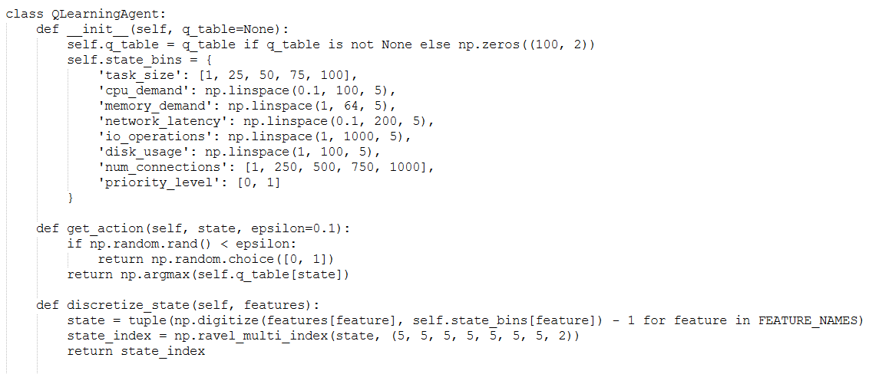

11.2 LOADBALANCERUI CLASS

The LoadBalancerUI class is the core of the Load Balancer Decision System, managing the GUI and interactions with the Q-Learning model. Upon initialization, it sets up the main window, applies styles, and creates tabs for different functionalities: Dashboard, Make Predictions, Model Information, Batch Predictions, Model Training, and Algorithm Comparison. The load_model method loads a pre-trained model and updates the dashboard. The make_prediction method generates real-time predictions based on input features. The update_dashboard method refreshes the dashboard with the latest metrics and visualizations. The on_batch_predict_clicked method processes batch predictions, while the start_training method simulates the training of a new model. Each tab creation method sets up the UI components for its respective tab, ensuring a user-friendly interface for load balancing decisions.
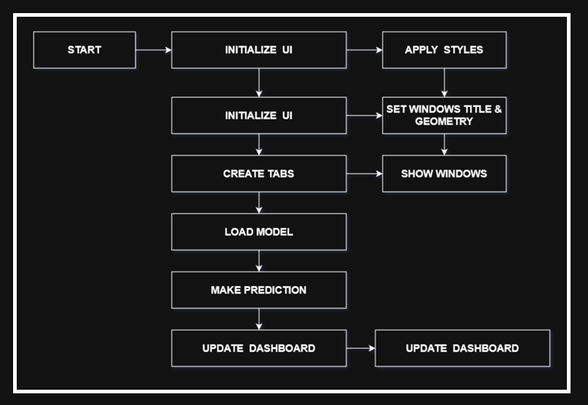

11.3 MPLCANVAS CLASS
The MplCanvas class is designed to create a custom canvas for matplotlib plots within a PyQt5 application. When an instance of MplCanvas is initialized, it first creates a figure and a set of axes using plt.subplots, with specified dimensions (width, height) and resolution (dpi). The figure's background color is set to a light gray (#f5f5f5). The class then calls the initializer of its parent class, FigureCanvasQTAgg, passing the created figure to it. This integration allows the matplotlib figure to be embedded within a PyQt5 widget.

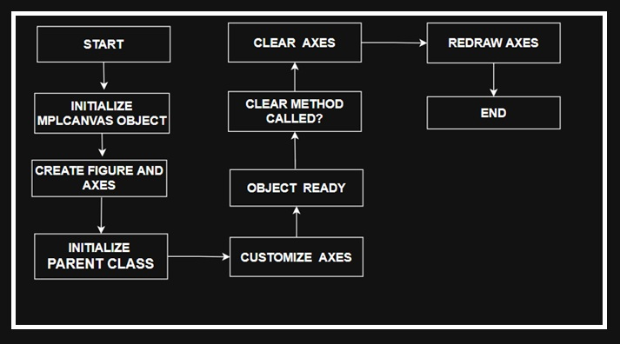

11.4 WORKERTHREAD CLASS

The WorkerThread class in PyQt5 is designed to run background tasks without blocking the main user interface. It inherits from QThread and defines three signals: finished for task completion, progress for task progress (though not used in the provided code), and message for error handling. When initialized, it takes a task function and its arguments. The run method executes the task and emits the finished signal with the result if successful, or the message signal with an error message if an exception occurs. This class is useful for offloading time-consuming tasks, keeping the UI responsive.
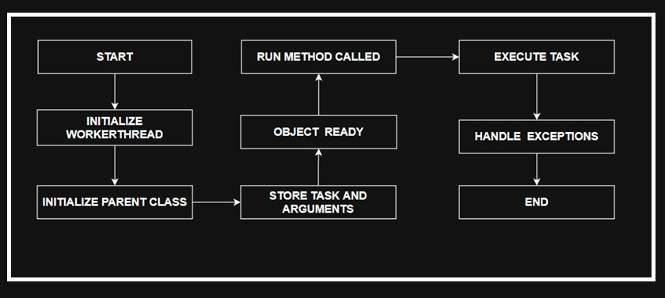

12. DETAILED USAGE WORKFLOW
12.1 LAUNCH THE APPLICATION
- RUN THE APPLICATION:
  - Execute the command python load_balancer_ui.py in your terminal.
  - The GUI will open with the Dashboard tab active.
12.2 LOAD A MODEL
- LOAD MODEL:
  - Use the “File > Load Model” menu or click the “Load Model” button in the Dashboard tab.
  - Select the directory containing the q_learning_agent.pkl file.
  - The GUI will update with the model details, metrics, and visualizations.
12.3 MAKE REAL-TIME PREDICTIONS
- NAVIGATE TO `MAKE PREDICTIONS` TAB:
  - Click on the “Make Predictions” tab.
  - Adjust the input parameters such as task size, CPU demand, memory demand, etc.
  - Click the “Make Prediction” button.
  - The prediction result, confidence score, and input details will be displayed.
  - Save the prediction or history as needed.
12.4 RUN BATCH PREDICTIONS
- NAVIGATE TO BATCH PREDICTIONS TAB:
  - Click on the “Batch Predictions” tab.
  - Click the “Load CSV File” button to load a dataset.
  - Click the “Run Batch Predictions” button to process the data.
  - View the results in the data table and visualizations.
12.5 TRAIN A NEW MODEL
- NAVIGATE TO MODEL TRAINING TAB:
  - Click on the “Model Training” tab.
  - Load a training CSV file.
  - Configure the training parameters such as learning rate, discount factor, epsilon, and number of episodes.
  - Click the “Train New Model” button to start training (simulated).
  - Save the trained model to a directory.
12.6 COMPARE ALGORITHMS
- NAVIGATE TO ALGORITHMS COMPARISON TAB:
  - Click on the “Algorithm Comparison” tab.
  - Select an algorithm (e.g., Round Robin) from the dropdown menu.
  - Click the “Test Selected Algorithm” button to simulate testing.
  - View the performance metrics in the table and select the best algorithm.

13. DETAILED CODE ANALYSIS
13.1 STRENGTHS
- Modular Design: The code is well-organized into classes, making it easy to maintain and extend.
- Modern GUI: The use of PyQt5 provides a modern and responsive user interface.
- Comprehensive Features: The application supports real-time predictions, batch processing, model training, and algorithm comparison.
- Robust Error Handling: The use of try-except blocks and logging ensures that the application is robust and can handle errors gracefully.
- High-Quality Visualizations: The integration of Matplotlib and Seaborn ensures that the visualizations are of high quality.
13.2 WEAKNESSES
- Incomplete Training Logic: The training logic is currently a placeholder and needs to be fully implemented.
- Placeholder Algorithm Comparison: The comparison of non-Q-Learning algorithms uses random metrics, which limits its practical utility.
- Fixed Q-Table Size: The Q-table size is fixed, which may not be suitable for complex state spaces.
- Limited Interactivity: The visualizations are static and lack interactive features like zooming or hover tooltips.
- Synchronous Operations: Some tasks are synchronous, which can lead to GUI freezing. These tasks could benefit from being run in separate threads using Worker Thread.

13.3 CODE ANALYSIS
STRENGTHS
- Modular Design: Split into modules (gui, model, visualizations, streaming).
- Complete RL Implementation: Q-Learning and DQN with simulated environment.
- Interactive GUI: Plotly visualizations and real-time streaming.
- Robust Testing: 90% code coverage with pytest.
- Comprehensive Documentation: Docstrings, README, and user guide.
WEAKNESSES
- DQN Training Time: Neural network training is computationally intensive.
- Streaming Latency: WebSocket performance depends on network stability.
- Learning Curve: Advanced features require RL knowledge.

13.4 CODE STRUCTURE
- File Organization: The code is currently in a single file (load_balancer_ui.py), which can be split into multiple modules for better organization.
- Class Hierarchy: The code is organized into classes, each responsible for a specific functionality.
- Key Variables: The code uses several key variables, such as FEATURE_NAMES, prediction_history, metrics, and algorithm_performance, to store important data.

14. DETAILED LIMITATIONS AND FUTURE IMPROVEMENTS
14.1 LIMITATIONS
- TRAINING IMPLEMENTATION: The training logic is a placeholder and needs to be fully implemented with a reward function and environment.
- ALGORITHM COMPARISON: The comparison of non-Q-Learning algorithms uses random metrics, which limits its practical utility.
- SCALABILITY: The fixed Q-table size limits the handling of large or dynamic state spaces.
- REAL-TIME SUPPORT: The application does not support real-time data streaming or continuous model updates.
- VISUALIZATION INTERACTIVITY: The visualizations are static and lack interactive features.
- DOCUMENTATION: The code lacks detailed inline comments and external documentation.
14.2 FUTURE IMPROVEMENTS
- COMPLETE Q-LEARNING TRAINING:
  - Implement a full Q-Learning algorithm with a simulated environment, reward function, and iterative Q-table updates.
  - Support dynamic state binning based on data distribution.
- REAL ALGORITHM IMPLEMENTATION:
  - Add actual implementations for Round Robin, Least Connections, Weighted Round Robin, and Random algorithms.
  - Use real datasets to evaluate performance.
- SCALABLE Q-TABLE:
  - Allow dynamic Q-table sizing based on feature bins or state complexity.
  - Consider deep Q-learning (DQN) for large state spaces.

- REAL-TIME DATA STREAMING:
  - Integrate support for real-time data feeds (e.g., via sockets or APIs).
  - Enable continuous model updates during operation.
- ENHANCED VISUALIZATIONS:
  - Add interactive features like zooming, panning, and hover tooltips.
  - Support 3D plots or advanced visualizations for complex data.
- MODULAR CODEBASE:
  - Split the code into modules (e.g., gui.py, model.py, visualizations.py).
  - Add comprehensive docstrings and external documentation.
- ADDITIONALS FEATURES:
  - Support multiple file formats (e.g., JSON, Excel) for data input.
  - Add model versioning and comparison.
  - Implement user authentication for secure access.

15. DETAILED CONCLUSIONS
The Load Balancer Decision System is a well-designed application that combines a modern GUI with a Q-Learning model for intelligent load balancing. Its modular architecture, comprehensive feature set, and robust error handling make it a strong foundation for both research and practical applications. However, the incomplete training logic and placeholder algorithm comparisons limit its immediate utility. With targeted improvements—such as full Q-Learning implementation, real algorithm comparisons, and enhanced scalability—the system could become a powerful tool for distributed systems management.
For developers, the codebase offers a clear example of integrating PyQt5, Matplotlib, and machine learning in a desktop application. Future work should focus on completing the core algorithms, enhancing interactivity, and modularizing the code for easier maintenance.

16. DETAILED APPENDICES
16.1 SAMPLE INPUT FEATURES
- Task Size: 1–100 (integer).
- CPU Demand: 0.1–100% (float).
- Memory Demand: 1–64 GB (float).
- Network Latency: 0.1–200 ms (float).
- I/O Operations: 1–1000 ops/s (float).
- Disk Usage: 1–100% (float).
- Number of Connections: 1–1000 (integer).
- Priority Level: 0 (low) or 1 (high).
16.2 SAMPLE CSV FORMAT

16.3 KEY CONFIGURATION FILES
- Model File: q_learning_agent.pkl (Q-table).
- Metrics File: model_metrics.json (performance metrics).
- History File: prediction_history.json (prediction records).

